**NAME : MADHANKUMAR N**

**ROLL NO : 727722EUIT510**

**CC 1**

**Q.NO 1**

**CODE :**

**package** com.selenium.test2.selenium1;

**import** org.openqa.selenium.By;

**import** org.openqa.selenium.WebDriver;

**import** org.openqa.selenium.WebElement;

**import** org.openqa.selenium.chrome.ChromeDriver;

**import** org.openqa.selenium.chrome.ChromeOptions;

**import** io.github.bonigarcia.wdm.WebDriverManager;

**public** **class** CC1{

**public** **static** **void** main(String[] args) **throws** InterruptedException {

// Set up the Chrome driver

WebDriverManager.*chromedriver*().setup();

ChromeOptions co=**new** ChromeOptions();

co.addArguments("--remote-allow-origins=*");

WebDriver driver=**new** ChromeDriver(co);

driver.get("https://www.saucedemo.com/inventory.html");

driver.manage().window().maximize();

// Log in with a valid username and password

WebElement usernameField = driver.findElement(By.*id*("user-name"));

WebElement passwordField = driver.findElement(By.*id*("password"));

WebElement loginButton = driver.findElement(By.*id*("login-button"));

usernameField.sendKeys("standard_user");

passwordField.sendKeys("secret_sauce");

Thread.*sleep*(3000);

loginButton.click();

// Add a product to the cart

WebElement addToCartButton = driver.findElement(By.*id*("add-to-cart-sauce-labs-backpack"));

addToCartButton.click();

Thread.*sleep*(3000);

// Verify that the product was added to the cart

WebElement cartBadge = driver.findElement(By.*id*("remove-sauce-labs-backpack"));

String t=cartBadge.getText();

**if**(t.equals("Remove")) {

System.***out***.println("1. Item is Added to Cart");

}

// View the contents of the cart

WebElement cartLink = driver.findElement(By.*className*("shopping_cart_badge"));

cartLink.click();

WebElement cart = driver.findElement(By.*className*("title"));

String a=cart.getText();

**if**(a.equals("Your Cart")) {

System.***out***.println("2. Your Cart is Viewed");

}

Thread.*sleep*(3000);

// Verify that the checkout form is displayed

WebElement checkoutButton = driver.findElement(By.*id*("checkout"));

checkoutButton.click();

WebElement check= driver.findElement(By.*className*("title"));

String b=check.getText();

**if**(b.equals("Checkout: Your Information")) {

System.***out***.println("3. Your Information Form is Displayed");

}

Thread.*sleep*(3000);

// Fill out the checkout form and product overview should be displayed

WebElement firstNameField = driver.findElement(By.*id*("first-name"));

WebElement lastNameField = driver.findElement(By.*id*("last-name"));

WebElement postalCodeField = driver.findElement(By.*id*("postal-code"));

WebElement continueButton = driver.findElement(By.*cssSelector*(".btn_primary.cart_button"));

firstNameField.sendKeys("John");

lastNameField.sendKeys("Doe");

postalCodeField.sendKeys("12345");

Thread.*sleep*(3000);

continueButton.click();

WebElement over= driver.findElement(By.*className*("title"));

String c=over.getText();

**if**(c.equals("Checkout: Overview")) {

System.***out***.println("4. Product Overview is Displayed");

}

Thread.*sleep*(3000);

//Name and price of the product should be displayed

WebElement productName = driver.findElement(By.*xpath*("//*[@id=\"item_4_title_link\"]/div"));

WebElement productPrice = driver.findElement(By.*xpath*("//*[@id=\"checkout_summary_container\"]/div/div[2]/div[8]"));

String name=productName.getText();

String price=productPrice.getText();

System.***out***.println("5. Product Name: "+name);

System.***out***.println(" "+price);

//Title and URL of the page

String tit=driver.getTitle();

**if**(tit.equals("Swag Labs")){

System.***out***.println("6. Title of the page is Correct");

}

String u=driver.getCurrentUrl();

**if**(u.equals("https://www.saucedemo.com/checkout-step-two.html")){

System.***out***.println("7. URL of the page is Correct");

}

}

}

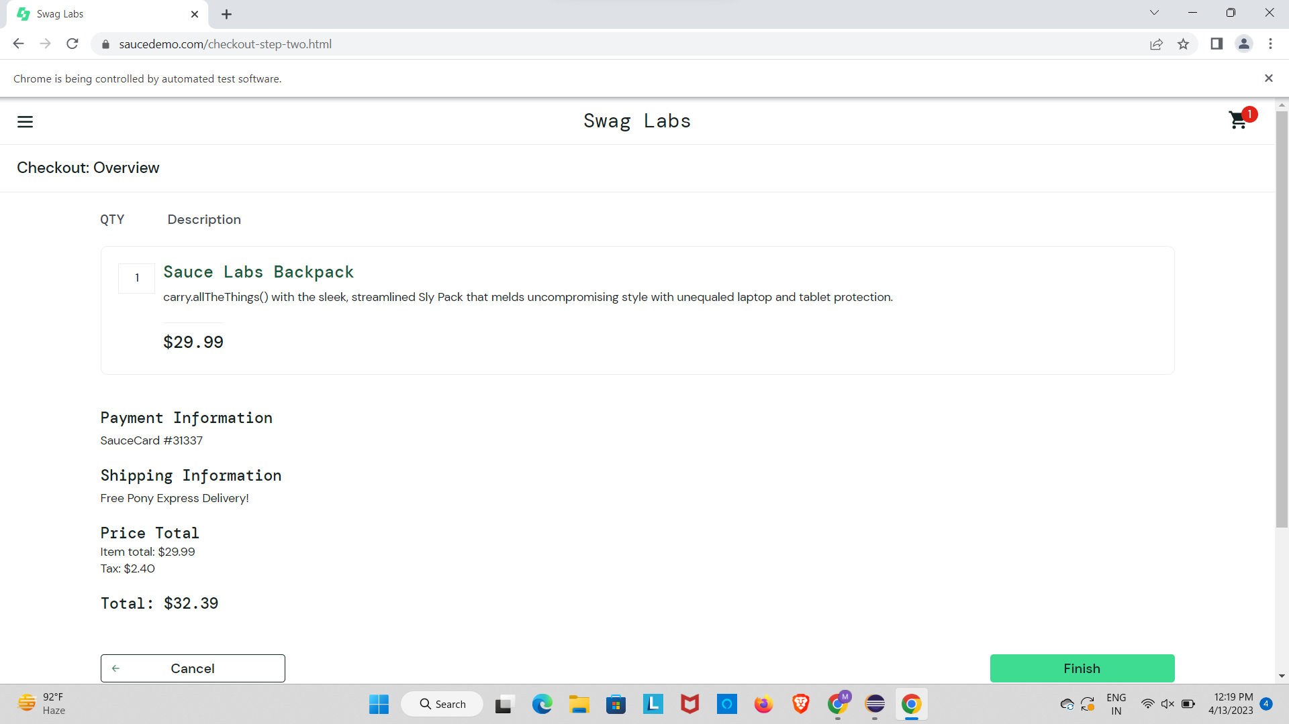

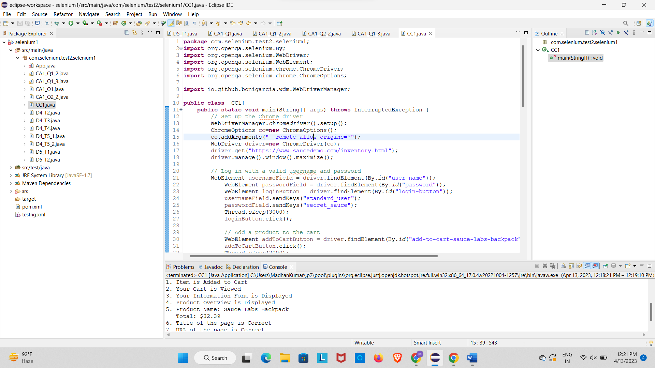

**Q.NO 2**

**CODE :**

**package** com.selenium.test2.selenium1;

**import** org.openqa.selenium.By;

**import** org.openqa.selenium.WebDriver;

**import** org.openqa.selenium.WebElement;

**import** org.openqa.selenium.chrome.ChromeDriver;

**import** org.openqa.selenium.chrome.ChromeOptions;

**import** org.openqa.selenium.support.ui.Select;

**import** io.github.bonigarcia.wdm.WebDriverManager;

**public** **class** CC1_2 {

**public** **static** **void** main( String[] args )**throws** InterruptedException

{

WebDriverManager.*chromedriver*().setup();

ChromeOptions co=**new** ChromeOptions();

co.addArguments("--remote-allow-origins=*");

WebDriver driver=**new** ChromeDriver(co);

driver.get("https://www.saucedemo.com/");

driver.manage().window().maximize();

WebElement sel=driver.findElement(By.*id*("user-name"));

sel.sendKeys("standard_user");

WebElement sel2=driver.findElement(By.*id*("password"));

sel2.sendKeys("secret_sauce");

WebElement sel3=driver.findElement(By.*id*("login-button"));

Thread.*sleep*(4000);

sel3.click();

WebElement sort1=driver.findElement(By.*className*("product_sort_container"));

sort1.click();

Select select= **new** Select(sort1);

select.selectByVisibleText("Name (A to Z)");

Thread.*sleep*(4000);

WebElement iden=driver.findElement(By.*xpath*("//*[@id=\"header_container\"]/div[2]/div/span/select/option[1]"));

**if**(iden.getText().equals("Name (A to Z)")) {

System.***out***.println("1.Verified that the user is able to apply the filter Name (A to Z)");

}

Thread.*sleep*(4000);

iden.click();

WebElement name=driver.findElement(By.*xpath*("//*[@id=\"item_4_title_link\"]/div"));

System.***out***.println("First product name while filtering from A-Z :-"+name.getText());

WebElement iden1=driver.findElement(By.*xpath*("//*[@id=\"header_container\"]/div[2]/div/span/select/option[2]"));

**if**(iden1.getText().equals("Name (Z to A)")) {

System.***out***.println("2.Verified that the user is able to apply the filter Name (Z to A)");

}

iden1.click();

Thread.*sleep*(4000);

WebElement name1=driver.findElement(By.*xpath*("//*[@id=\"item_3_title_link\"]/div"));

System.***out***.println("First product name while filtering from Z-A :-"+name1.getText());

WebElement iden2=driver.findElement(By.*xpath*("//*[@id=\"header_container\"]/div[2]/div/span/select/option[3]"));

**if**(iden2.getText().equals("Price (low to high)")) {

System.***out***.println("3.Verified that the user is able to apply the filter Price (low to high)");

}

iden2.click();

Thread.*sleep*(4000);

WebElement name2=driver.findElement(By.*xpath*("//*[@id=\"item_2_title_link\"]/div"));

System.***out***.println("First product name while filtering from Price (low to high) :-"+name2.getText());

WebElement iden3=driver.findElement(By.*xpath*("//*[@id=\"header_container\"]/div[2]/div/span/select/option[4]"));

**if**(iden3.getText().equals("Price (high to low)")) {

System.***out***.println("4.Verified that the user is able to apply the filter Price (high to low)");

}

iden3.click();

Thread.*sleep*(4000);

WebElement name3=driver.findElement(By.*xpath*("//*[@id=\"item_5_title_link\"]/div"));

System.***out***.println("First product name while filtering from Price (high to low) :-"+name3.getText());

}

}

